CSXXX (Day and Time of the Class)

CAPSTONE COURSE

San Francisco Bay University, Fremont, CA

FINAL REPORT

Term XXXX 202X


Prof. Ahmed Banafa

Name of the Project

Submission Date

Team Members
Ayoyimika Ajibade | 144210
Student Name | Student ID
Student Name | Student ID
Student Name | Student ID

Abstract

This is a summary of the paper.

Single block paragraph.
Double Spaced
If this was a study, it would include what/who was studied; the process; and the outcome.

4. Database and Backend API Management (Ayo)
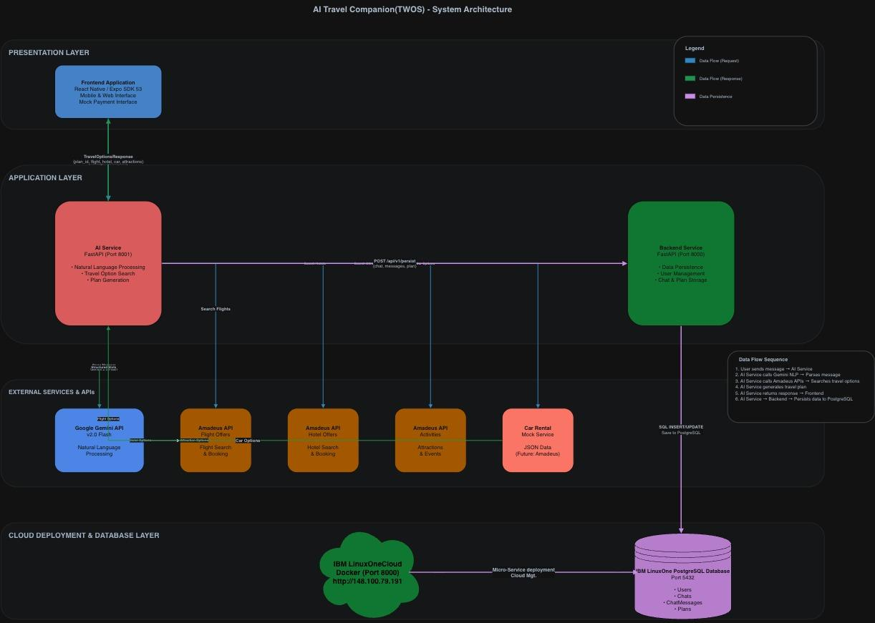
Figure 1 - High-Level System Architecture
Description: Diagram showing the overall system architecture with frontend, AI, backend, database,
and external service interactions.

Key Components and Their Interactions

1. Client Layer
Mobile Application (React Native with Expo)
The mobile application serves as the primary user interface for the system. Built with React Native and Expo SDK 53, the application provides:
- Chats Interface: Natural language chat interface for travel planning
- Authentication: Secure user registration, login, and session management
- Plan Management: View, compare, and manage generated travel plans
- Chat History: Access to chat history and saved plans
- RESTful API Integration: Direct HTTPS communication with backend services
The application communicates exclusively through synchronous HTTP/REST API calls, ensuring compatibility with standard mobile networking environments.

2. AI Service (Entry Point Service)
Technology: FastAPI application running in Docker container (Port 8000)
Purpose: The AI Service serves as the primary entry point for all client interactions and handles the system's intelligent processing layer. This service is responsible for:

Natural Language Processing (NLP):
- Receives user messages in natural language format
- Utilizes Google Gemini 2.0 Flash API for intent extraction and entity recognition
- Parses unstructured user input into structured travel parameters (origin, destination, dates, budget, preferences)
- Maintains chat context using slot-based tracking (ULID slot_id)

Travel Data Aggregation:
- Integrates with Amadeus for Developers APIs for real-time travel information:
  - Flight Offers API: Searches and retrieves flight options based on origin, destination, and dates
  - Hotel Offers API: Queries hotel availability and pricing
  - Activities API: Discovers local attractions and activities
  - Mock Car Rental Service: Provides car rental recommendations (prepared for future Amadeus Car API integration)
- Aggregates travel options into comprehensive travel plans
- Applies filtering and selection algorithms to identify optimal options

Chat Management:
- Generates unique session identifiers (slot_id) using ULID for session continuity
- Merges new user input with existing conversation state
- Determines information completeness and prompts for missing required parameters
- Generates contextual, natural language responses to guide users through the planning process

Plan Generation:
- Automatically generates travel plans when all required information is collected
- Creates structured JSON responses containing flight, hotel, car rental, and attraction recommendations
- Calculates total pricing and provides budget analysis
- Returns immediate responses to users while asynchronously persisting data

Data Persistence Coordination:
- Makes non-blocking HTTP requests to the Backend Service to persist chat conversations, messages, and generated plans
- Ensures data durability without impacting user response times

3. Backend Service (Persistence & Management Layer)
Technology: FastAPI application running in Docker container (Port 8001)
Purpose: The Backend Service handles all data persistence, user management, and administrative operations:

Authentication & Authorization:
- User Registration: Creates new user accounts with username, email, and encrypted password storage
- Login/Logout: JWT-based authentication with access tokens (8-hour expiration) and refresh tokens (30-day expiration)
- Token Management: Implements token blacklisting for secure logout functionality
- Password Management: Supports password reset with temporary password generation and secure password change functionality
- Optional Authentication: Supports both authenticated and anonymous user sessions

User Management:
- Profile management (retrieve and update user information)
- User preferences storage (flexible JSON-based preference system)
- Last login tracking and account status management

Chat Management:
- Chat session creation and retrieval (linked by slot_id for anonymous users or user_id for authenticated users)
- Chat status management (draft, booked, confirmed, cancelled)
- Chat ownership and access control
- Chat deletion with cascade deletion of associated plans and messages
- Support for shareable chat links via unique share_code

Plan Management:
- Travel plan storage and retrieval
- Plan association with chat sessions
- Plan deletion and management
- Public plan access (unauthenticated plan viewing via plan_id)

Message Persistence:
- Stores both user messages and AI-generated responses
- Maintains chat history with role-based message classification (user/bot)
- Links messages to chat sessions via chat_id and slot_id
- Preserves AI response metadata and structured data

Database Interaction:
- Direct SQLAlchemy/SQLModel ORM interaction with PostgreSQL
- Repository pattern for data access abstraction
- Service layer for business logic encapsulation
- Transaction management and data integrity enforcement

4. Data Layer
PostgreSQL Database (IBM Cloud Databases or Self-Hosted)
The system employs PostgreSQL 13+ as the primary persistent storage solution:

Schema Overview:
- users: User accounts, authentication credentials, and profile information
- user_preferences: Flexible JSON-based user preference storage
- token_blacklist: JWT token invalidation tracking (supports secure logout)
- chats: Travel chat sessions with comprehensive travel parameters
- chat_messages: Individual messages within conversations (user and bot messages)
- plans: Generated travel plans with flight, hotel, car, and attraction data stored as JSONB

Design Characteristics:
- UUID primary keys for all entities
- Timestamps (created_time, updated_time) for audit trails
- Foreign key relationships with appropriate cascade behaviors
- Indexes on frequently queried fields (user_id, chat_id, slot_id, share_code)
- JSONB fields for flexible schema-less data storage (travel options, preferences, metadata)

Data Access Pattern:
- All persistent data operations go through the Backend Service
- Direct database access is not exposed to clients or the AI Service
- The repository pattern ensures consistent data access patterns
- The service layer enforces business logic and validation rules

5. External Services & APIs
AI Provider - Google Gemini 2.0 Flash:
- Purpose: Natural language understanding and parsing
- Integration: REST API calls with JSON mode enabled
- Authentication: API key-based authentication
- Capabilities: Extracts structured travel parameters from conversational input, generates natural language responses

Travel Data Provider - Amadeus for Developers:
- Purpose: Real-time travel data aggregation
- Integration: OAuth2 client credentials flow with REST API calls
- Endpoints:
  - Flight Offers API: Comprehensive flight search and pricing
  - Hotel Offers API: Hotel availability and pricing information
  - Activities API: Local attractions and activities discovery
- Authentication: OAuth2 client credentials (API key and secret)
- Data Quality: Live, real-time data from travel industry providers

Future Integration - Car Rental API:
- Currently uses a mock data service for car rental recommendations
- Architecture prepared for Amadeus Car Rental API integration
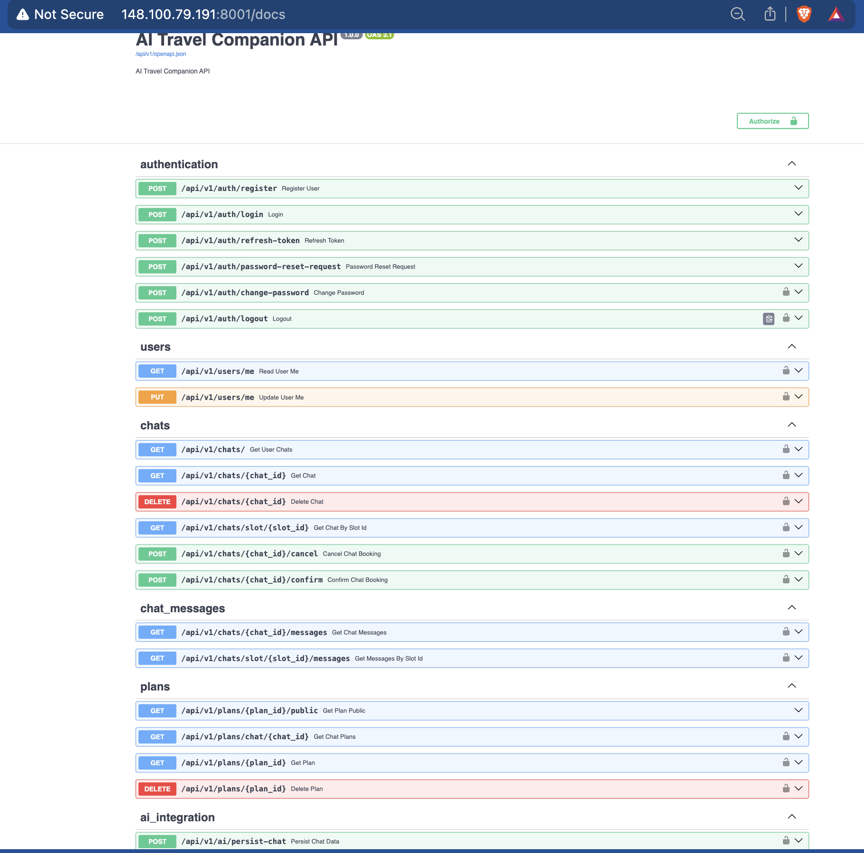

Figure 2 - API Route Structure
Description: Visual representation of
the API routes and their HTTP
methods.
Example:
Auth & User Mgt: POST /auth/login,
GET /users/me.
Chat & Plans Mgt: GET
/plan/{plan_id}/, GET /chats, DELETE
/chats/{chat_id}..
AI Integration: POST ai/chats/

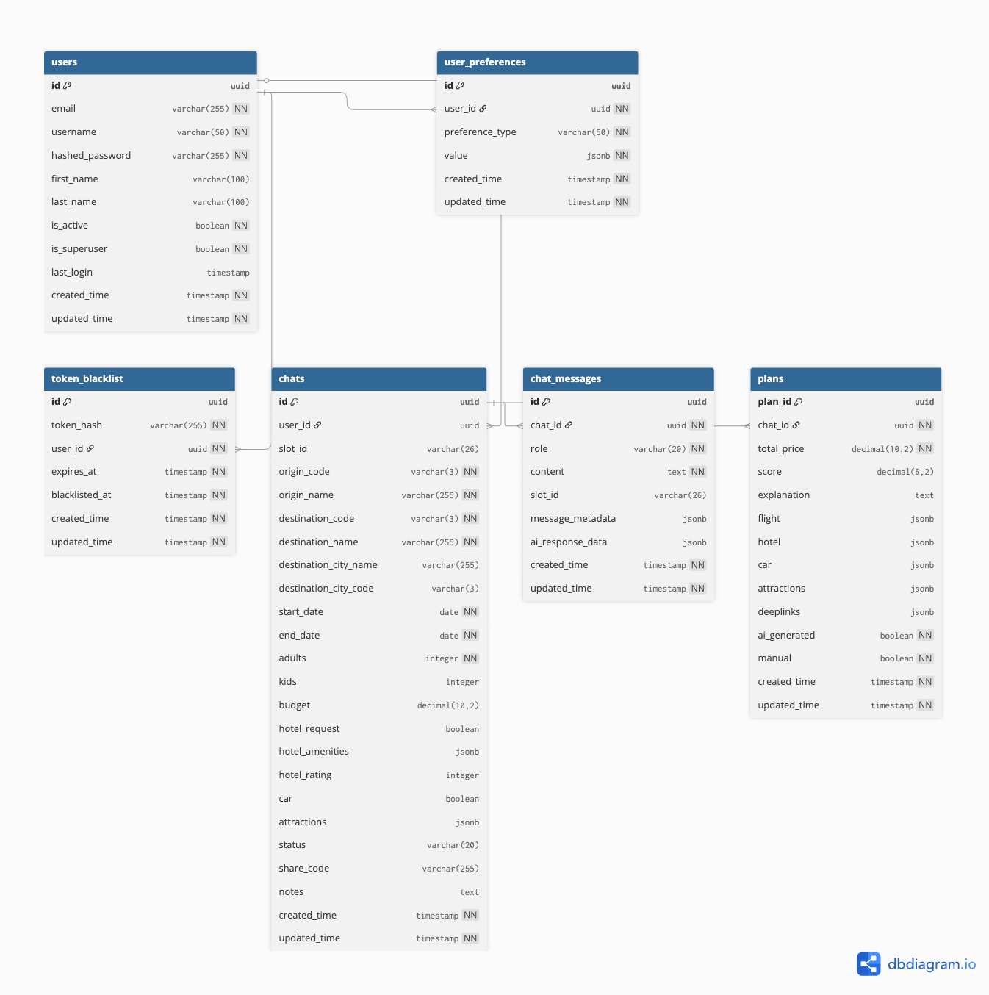

Figure 3 - Database
Schema and Models
Description: ERD
showing tables and their
relationships. Robust,
relational, JSONB
support for flexible
schema (flight/hotel
data). The stated
requirement.

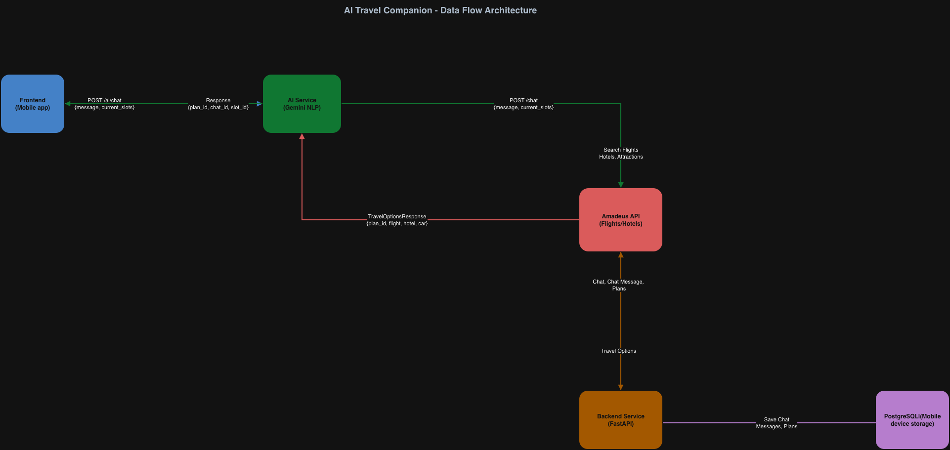

Figure 4 - TWOS DataFlow

Description: Example of data flow with the samples of request and response data.

1. User sends message → AI Service
2. AI Service calls Gemini NLP → Parses message
3. AI Service calls Amadeus APIs → Searches travel options
4. AI Service generates travel plan
5. AI Service returns response → Frontend
6. AI Service → Backend → Persists data to PostgreSQL

Full User Authentication & Security Flow With JWT, with full security measures
Implemented
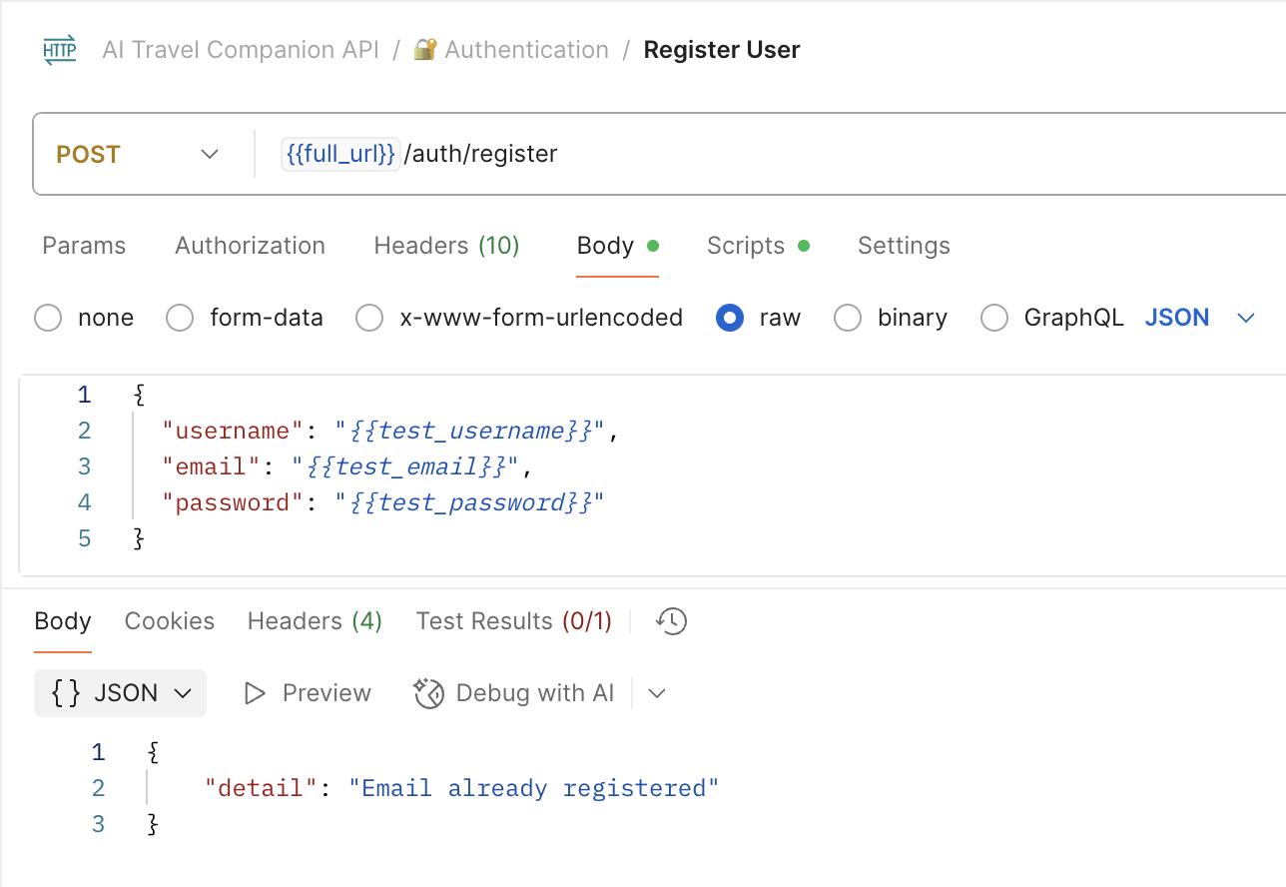
Figure 5 - User Register Flow
POST /api/v1/auth/register - User registration
(requires username, email, and password only)

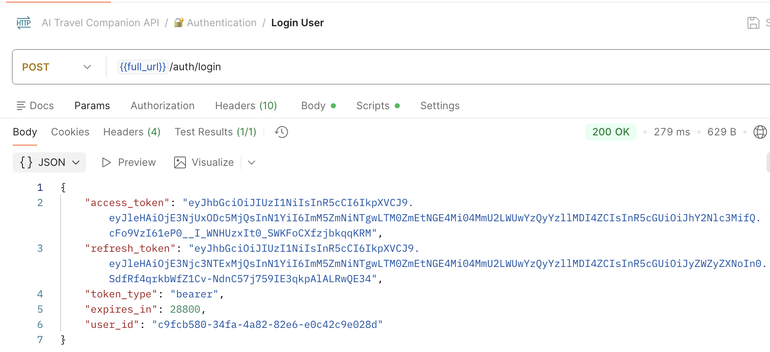

Figure 6 - User Login Flow
POST /api/v1/auth/login - Uses email/username
and password to generate access and refresh tokens

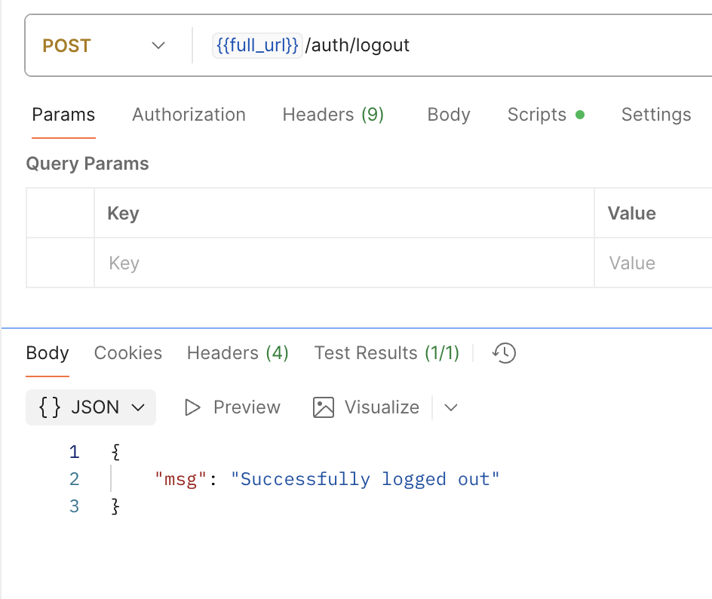

Figure 7 - User Logout Flow
POST /api/v1/auth/logout - Server-side logout
tracking for audit purposes(frontend will handle logout
by removing the user token from the browser session)

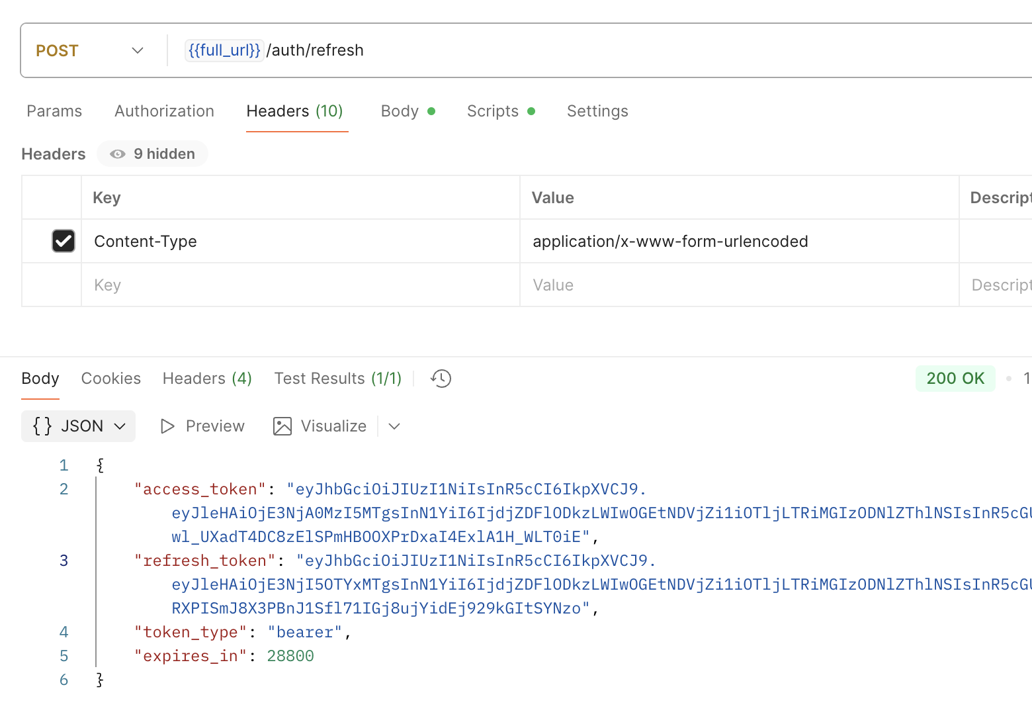
Figure 8 - User Token Management Flow
POST /api/v1/auth/refresh -Access tokens expire in 8
hours, refresh tokens in 30 days

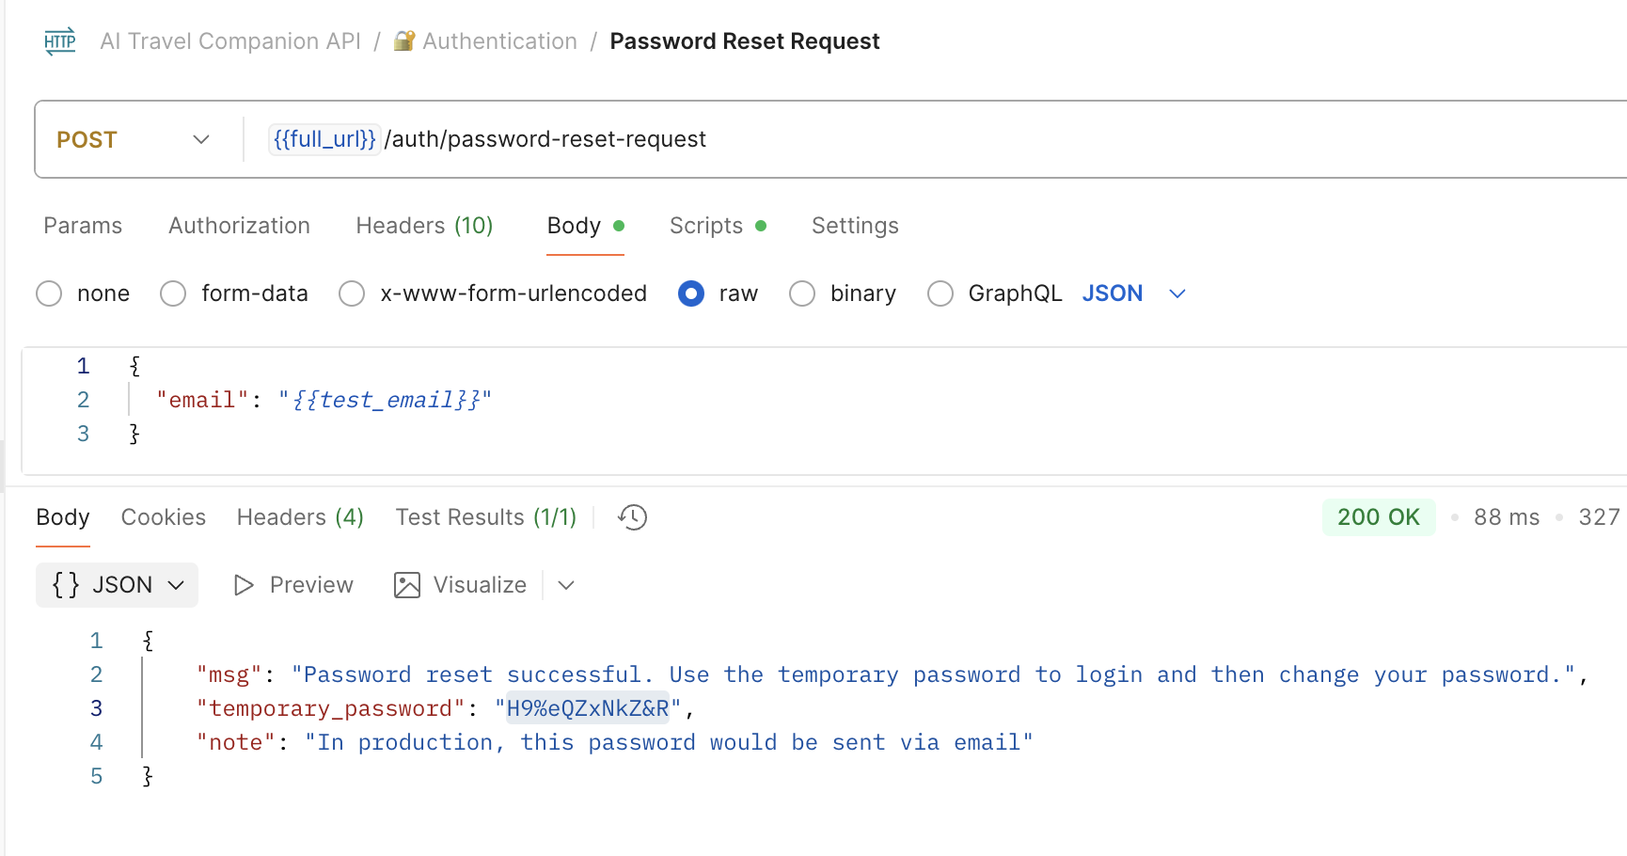
Figure 9 - User Password Reset Flow
POST /api/v1/auth/password-reset-request - Generates temporary passwords for secure password recovery
Password Reset Flow(Production)
1. User requests a password reset via email
2. The system generates a temporary password
3. User logs in with a temporary password to get an access token
4. User changes password using the change-password endpoint with an access token

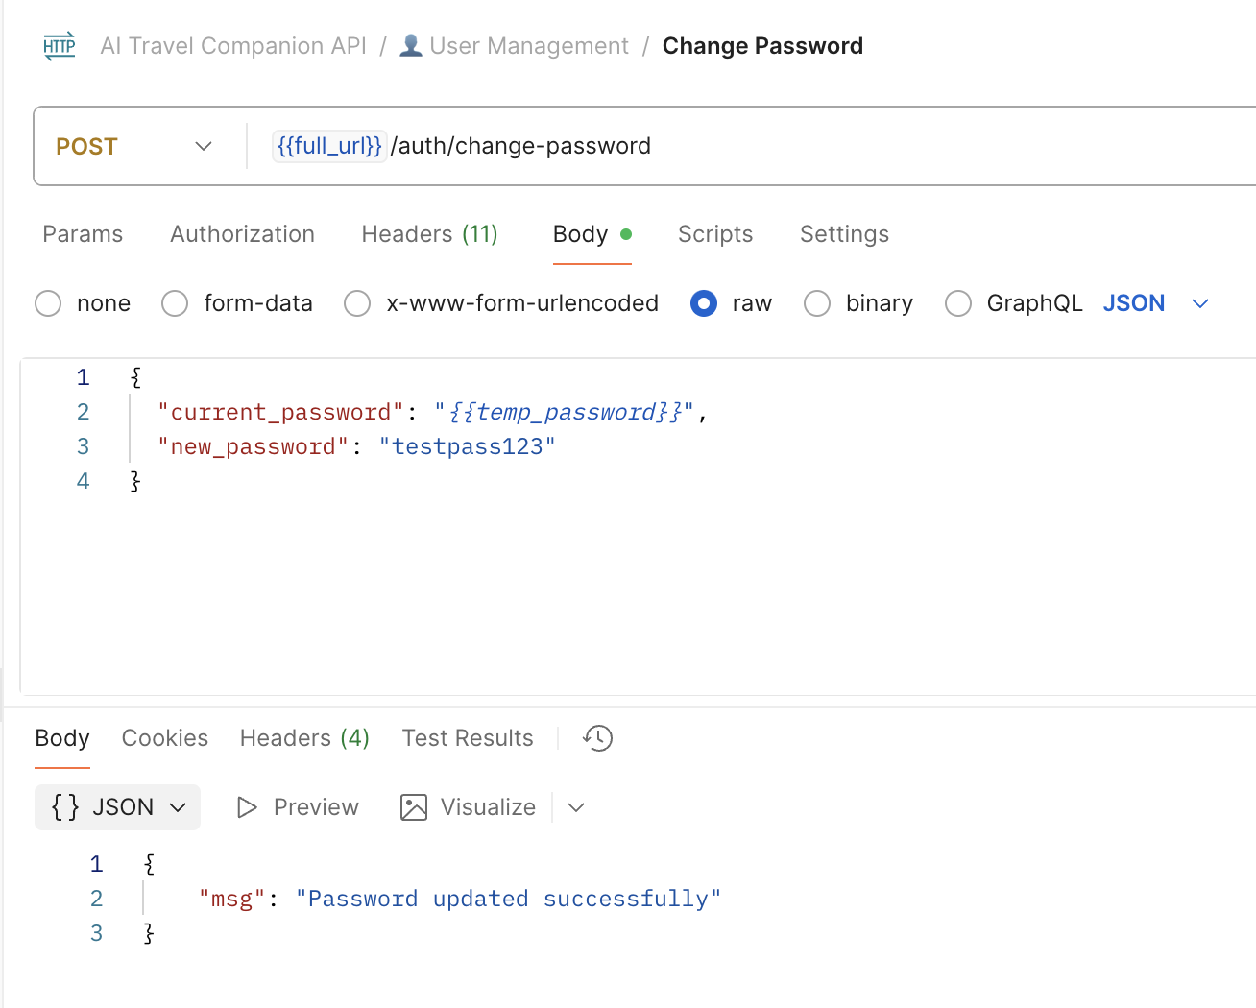

Figure 10 - User Password Change Flow
POST /api/v1/auth/change-password - Allows users to change passwords with current password verification

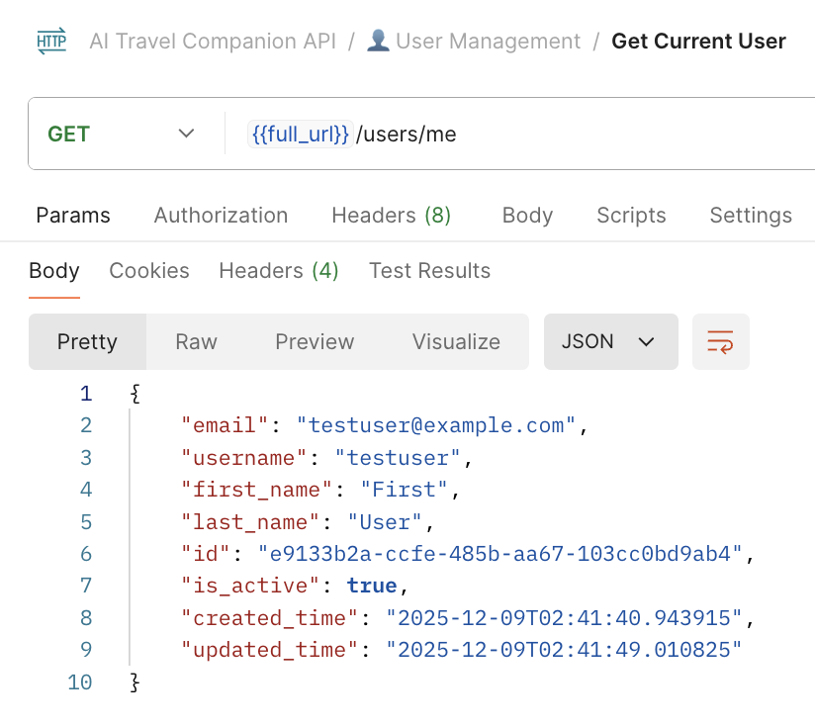

Figure 11 - Verify User is authenticated
GET /api/v1/users/me - Get current user profile

Full Chats, Chat messages, and Plans Flow, with optional authentication measures implemented
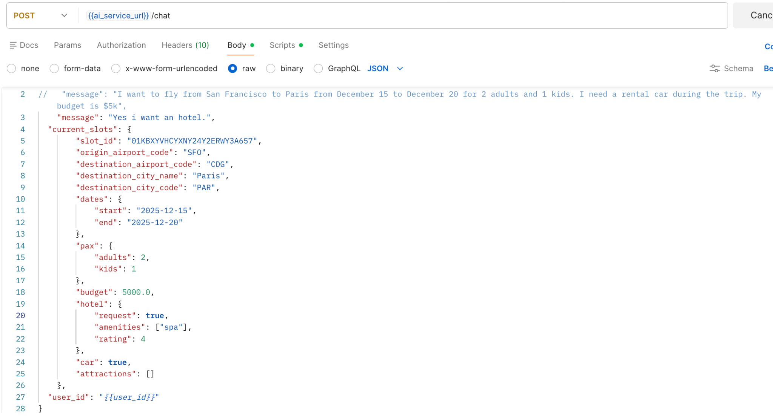

Figure 12 - Chat sample request
POST chat/ - POST user messages to return plans with flight, hotel, attractions, and cars, and accessible to both unauthenticated and authenticated users

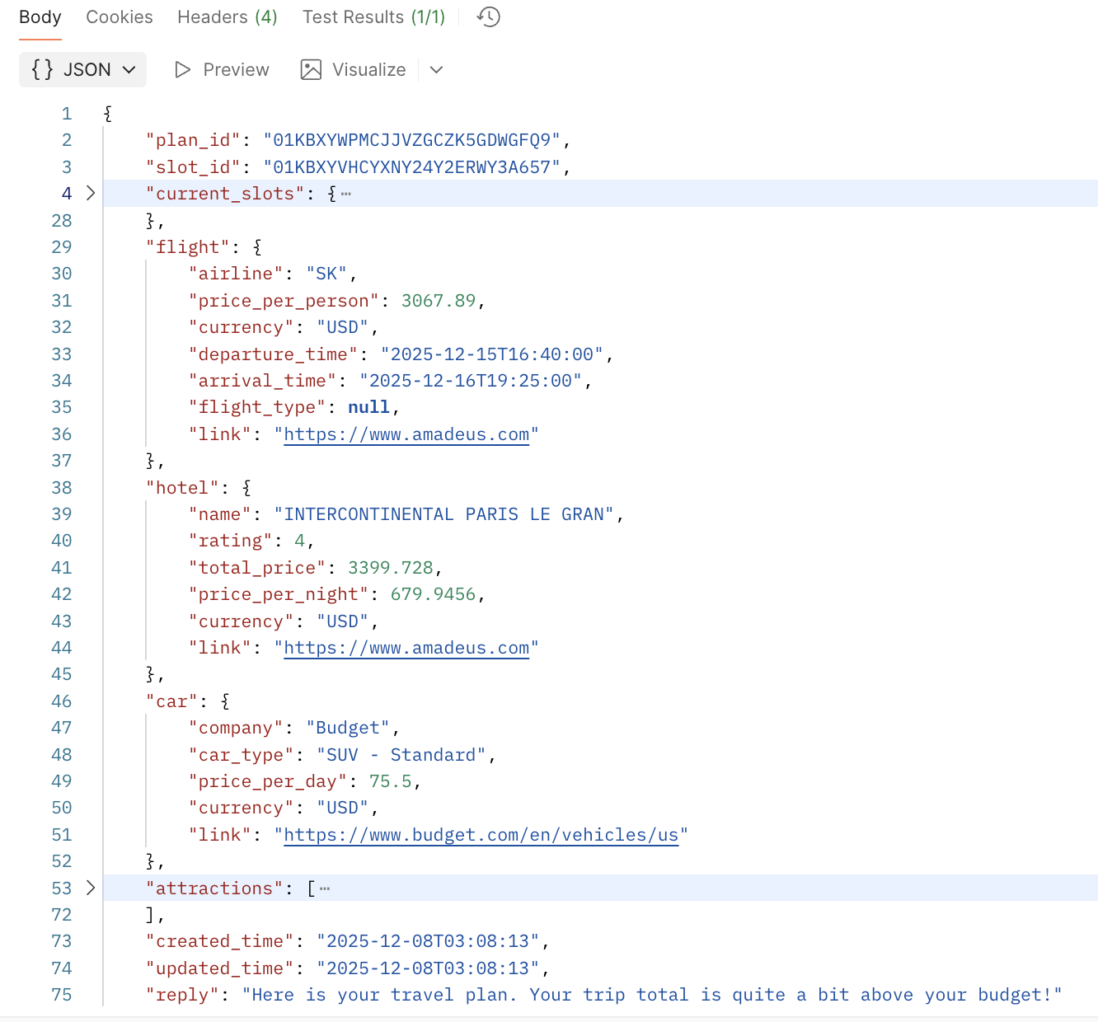
Figure 13 - Chat sample response
POST chat/ - POST user messages to return plans with flight, hotel, attractions, and cars, and accessible to both unauthenticated and authenticated users

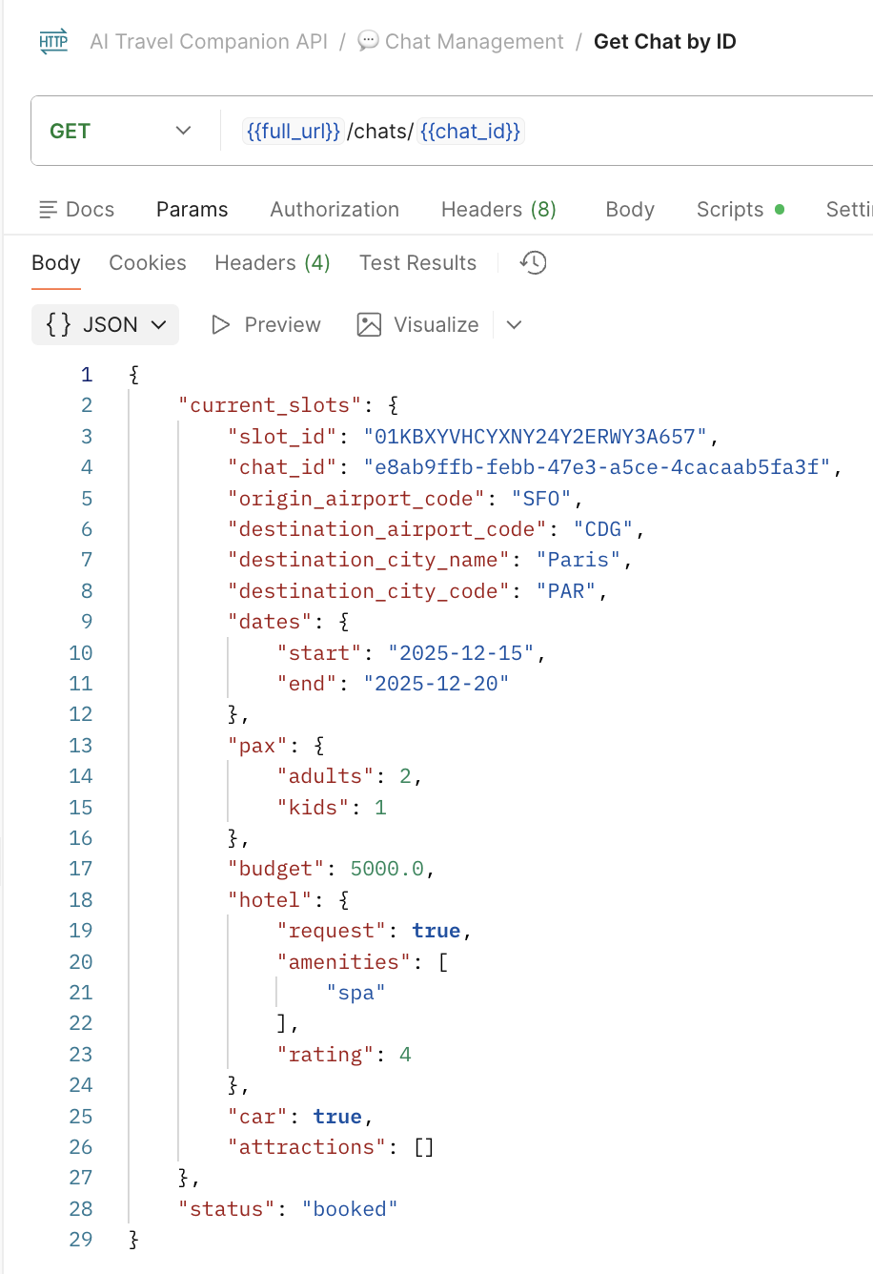
Figure 14 - Get Chat by ID
/chat/{{chat_id}}: it retrieves chat history from the DB by ID for only authenticated users

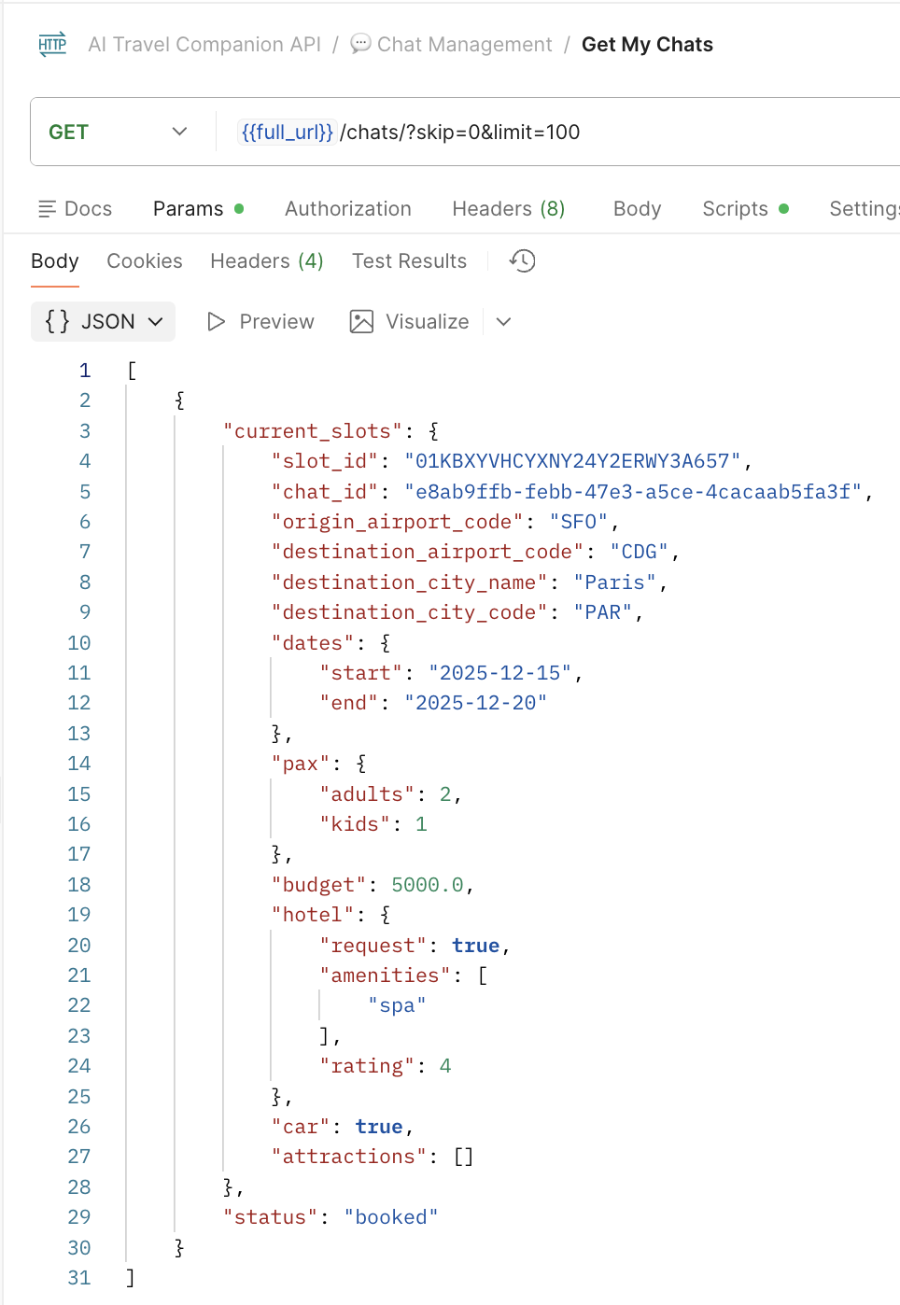

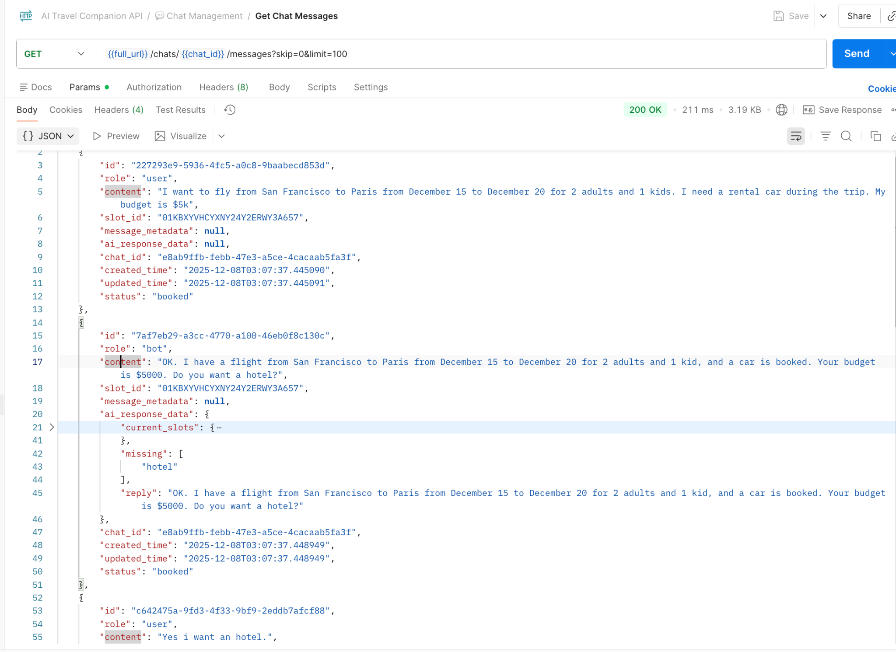
Figure 16 - Get Chat Messages
/chat/{{chat_id}}/message}: retrieves individual messages and the AI bot response, plus timestamp

Figure 15 - Get Chats
/chat/}: it retrieves all chat history from the DB for only
authenticated users, with pagination of 100 chats per page
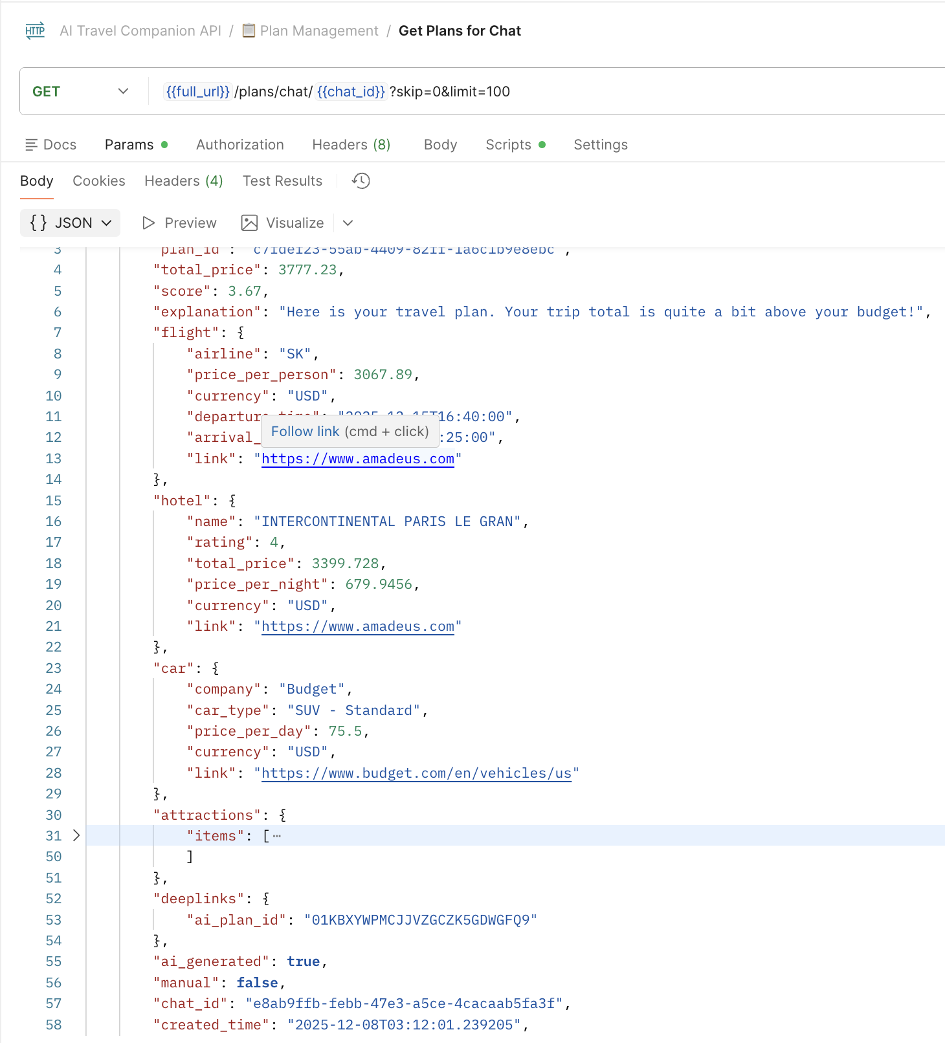

Figure 17 - Get Chat Plans
plans//chat/{{chat_id}}}: retreives individual chat AI generated plans with the
chat_id or slot_id for optimized plan generation based on analyzing
user behavior

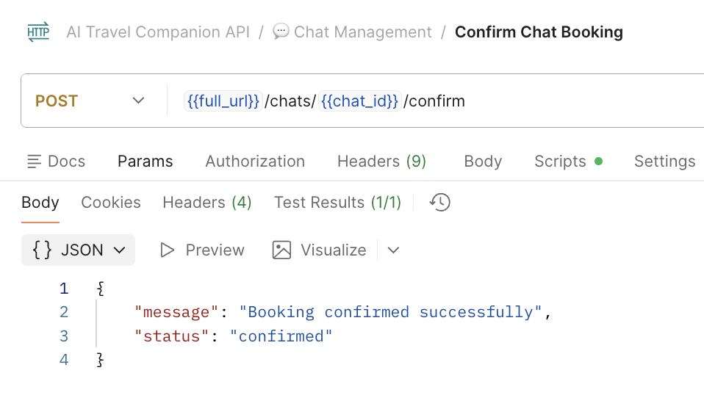

Figure 18 - Confirm Chat bookings
chats/{{chat_id}}/confirm: update chats status to confirm when flight, hotels, cars, and attraction bookings are

5. Cloud Deployment and Infrastructure (Ayo)
Containerization:
- Docker: All services are containerized using Docker for consistent deployment
- Docker Compose: Local development and production orchestration
- Multi-stage Builds: Optimized Docker images for production deployment
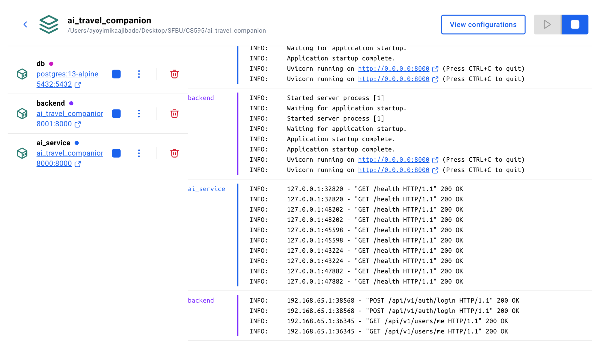

Figure 19 - Docker logs and services deployed

Containerized Services:
● AI Service: Fast API entry port
container for AI processing (8000)
● Backend API: FastAPI-based
RESTful service port (8001)
● Database: PostgreSQL 13
(s390x architecture compatible)
● Networking: Docker bridge
network (ai_travel_network)

Deployment Architecture:
- LinuxONE Virtual Machines: Production deployment target (IBM Cloud or on-premises)
- Docker Hub: Container image registry for image distribution
- GitHub Actions: Continuous Integration/Continuous Deployment (CI/CD) pipeline
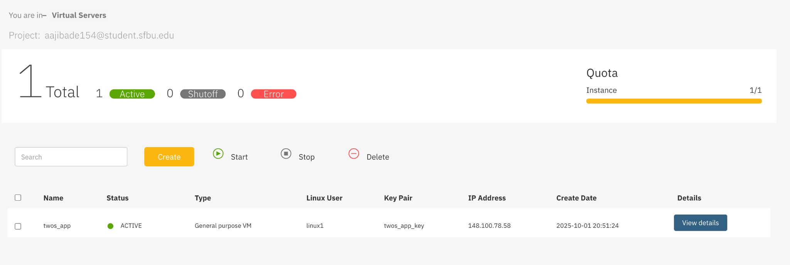
Figure 20 - IBM LinuxOne virtual server
Prerequisites:
● Docker CE for IBM Z/LinuxONE and Docker Compose
● Sufficient storage (min 20GB recommended)
● Leverage LinuxONE's vertical scaling capabilities
● Adjust CPU/Memory allocations in the compose file
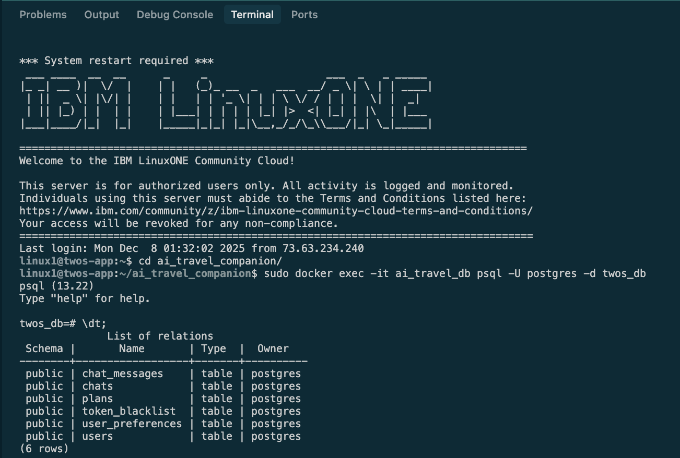
Figure 21 - IBM LinuxOne PostgreSQL virtual server

Sample Database Table
Description: Example of database tables in VM.
● Open ports: 5432 (Database)

CI/CD Pipeline:
- Build Phase:
  - Compiles and packages backend and AI service code
  - Creates optimized Docker images
  - Tags images with version metadata (branch, commit SHA, latest)
- Push Phase:
  - Pushes images to Docker Hub registry
  - Maintains image versioning and caching strategies
- Deploy Phase:
  - SSH-based deployment to target LinuxONE VMs
  - Dynamically generates production docker-compose configuration
  - Performs rolling updates with zero-downtime deployment strategies
  - Verifies service health post-deployment

Service Orchestration:
- Docker Compose: Production service orchestration on target VMs
- Health Checks: Automated health monitoring for all services
- Dependency Management: Service startup ordering (database → backend → AI service)
- Networking: Isolated Docker network for inter-service communication

Optional Infrastructure Components:
- Nginx Reverse Proxy: Optional load balancing and SSL termination (not currently in active deployment)
- Multiple VM Deployment: Support for horizontal scaling across multiple LinuxONE VMs

Scalability & Performance

1. Horizontal Scaling
- AI Service: Stateless design allows multiple instances
- Backend Service: Can be scaled independently
- Database: PostgreSQL supports read replicas for scaling reads

2. Response Time Optimization
- Immediate User Responses: Non-blocking persistence
- Parallel API Calls: Concurrent Amadeus API requests
- Efficient Database Queries: Indexed fields and optimized queries

3. Resource Management
- Connection Pooling: SQLAlchemy connection pooling
- Container Resource Limits: Docker resource constraints
- Health Monitoring: Automated health checks and restart policies

Conclusion
The AI Travel Companion system demonstrates a modern, scalable architecture that effectively separates intelligent conversational processing from data persistence and user management. The microservices design enables independent scaling, clear responsibility boundaries, and future extensibility. The system's focus on immediate user response times combined with reliable data persistence creates a responsive user experience while maintaining data integrity and durability.
The architecture's containerization and CI/CD pipeline ensure consistent, automated deployments, while the PostgreSQL-based data layer provides robust, transactional data management. The integration of cutting-edge AI (Google Gemini) with industry-standard travel data APIs (Amadeus) creates a powerful platform for intelligent travel planning assistance.

Conclusion
This is the summary of your paper. It should not be the same as the abstract, although it may include some of the same information. Conclusions are at least a paragraph long.
References

Lipsky, G.A. (1950). John Quincy Adams: His Theory and Ideas. New York: Thomas Y.

Crowell.

Lord, L. (2003). A first lady of many firsts. US News and World
Report, 135(20). Retrieved February 16, 2004, from Academic
Search Elite database.

https://dbdiagram.io/d/AI_Travel_Companion-68be1d8461a46d388ede1ce4

